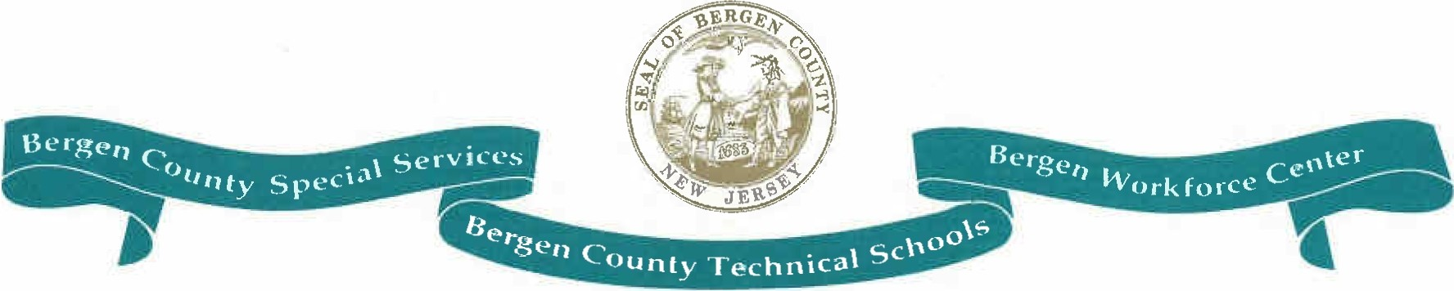

BERGEN COUNTY TECHNICAL SCHOOLS *I* SPECIAL SERVICES

District Administrative Office

327 E. Ridgewood Avenue, Paramus, New Jersey 07652 • Tel. (201) 343-6000 • Fax (201) 996-7246

Richard Panicucci

Assistant Superintendent of Curriculum and Instruction

September 1, 2016

Dear Parent/Guardian:

As a parent or guardian of a student attending one of the schools of the Bergen County Technical Schools District, you have a right to request information regarding the professional qualifications of the classroom teachers who instruct your child. Federal Law (NCLB) allows you to request this information and that it be provided to you in a timely manner should you request it.

Specifically, you have the right to request whether the teacher has been licensed by the New Jersey Department of Education (NJ DOE), whether a staff member has been permitted to teach under emergency certification provided by the NJ DOE, the

teacher's college major and any advanced degrees held, and whether any teacher's aide

who provides services to your child meets the qualifications of the NJ DOE.

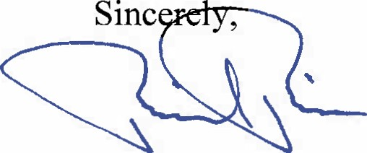If you would like to receive any of this information, please provide a written request addressed to me.

Richard Panicucci

RP:dm