**Precalculus/Trigonometry**

This course is intended for students who will be taking Precalculus/Trigonometry during the upcoming school year, or who have already taken Precalculus/Trigonometry and are looking for review and reinforcement. **This course assumes an understanding of all Algebra II topics**. Please take the Precalculus/Trigonometry placement test before registering. A score of 70% or higher is recommended to enroll in this course.

**Course Topics**: Functions (Power, Polynomial, Rational, Exponential, Logarithmic and Trigonometric), Trigonometric Identities and Equations, Systems of Equations and Matrices, Conic Sections and Parametric Equations, Vectors, Polar Coordinates and Complex Numbers, Sequences and Series, Limits and Derivatives, Statistics

**Precalculus/Trigonometry Placement Test**

Complete the following questions without the use of a calculator.

1. Identify the vertex and y-intercept of <math xmlns="http://www.w3.org/1998/Math/MathML" display="block" data-is-equatio="1" data-latex="y=-3\left(x+2\right)^2+5"><mi>y</mi><mo>=</mo><mo>−</mo><mn>3</mn><msup><mrow data-mjx-texclass="INNER"><mo data-mjx-texclass="OPEN">(</mo><mi>x</mi><mo>+</mo><mn>2</mn><mo data-mjx-texclass="CLOSE">)</mo></mrow><mn>2</mn></msup><mo>+</mo><mn>5</mn></math>.
2. Simplify the expression <math xmlns="http://www.w3.org/1998/Math/MathML" display="block" data-is-equatio="1" data-latex="\left(2+4i\right)\left(3-2i\right)"><mrow data-mjx-texclass="INNER"><mo data-mjx-texclass="OPEN">(</mo><mn>2</mn><mo>+</mo><mn>4</mn><mi>i</mi><mo data-mjx-texclass="CLOSE">)</mo></mrow><mrow data-mjx-texclass="INNER"><mo data-mjx-texclass="OPEN">(</mo><mn>3</mn><mo>−</mo><mn>2</mn><mi>i</mi><mo data-mjx-texclass="CLOSE">)</mo></mrow></math>.
3. Write the expression (x + 6)(x – 4) as a polynomial in standard form.
4. Divide the polynomials: <math xmlns="http://www.w3.org/1998/Math/MathML" display="block" data-is-equatio="1" data-latex="\left(x^4+15x^3-77x^2+13x-36\right)\div\left(x-4\right)"><mrow data-mjx-texclass="INNER"><mo data-mjx-texclass="OPEN">(</mo><msup><mi>x</mi><mn>4</mn></msup><mo>+</mo><mn>15</mn><msup><mi>x</mi><mn>3</mn></msup><mo>−</mo><mn>77</mn><msup><mi>x</mi><mn>2</mn></msup><mo>+</mo><mn>13</mn><mi>x</mi><mo>−</mo><mn>36</mn><mo data-mjx-texclass="CLOSE">)</mo></mrow><mo>÷</mo><mrow data-mjx-texclass="INNER"><mo data-mjx-texclass="OPEN">(</mo><mi>x</mi><mo>−</mo><mn>4</mn><mo data-mjx-texclass="CLOSE">)</mo></mrow></math>.
5. Find the root: <math xmlns="http://www.w3.org/1998/Math/MathML" display="block" data-is-equatio="1" data-latex="\sqrt[3]{-\frac{125}{343}}"><mroot><mrow><mo>−</mo><mfrac><mn>125</mn><mn>343</mn></mfrac></mrow><mn>3</mn></mroot></math>.
6. Write the equation in logarithmic form: <math xmlns="http://www.w3.org/1998/Math/MathML" display="block" data-is-equatio="1" data-latex="6^4=1296"><msup><mn>6</mn><mn>4</mn></msup><mo>=</mo><mn>1296</mn></math>.
7. Simplify <math xmlns="http://www.w3.org/1998/Math/MathML" display="block" data-is-equatio="1" data-latex="\left(3xy^3\right)^2\left(xy\right)^6"><msup><mrow data-mjx-texclass="INNER"><mo data-mjx-texclass="OPEN">(</mo><mn>3</mn><mi>x</mi><msup><mi>y</mi><mn>3</mn></msup><mo data-mjx-texclass="CLOSE">)</mo></mrow><mn>2</mn></msup><msup><mrow data-mjx-texclass="INNER"><mo data-mjx-texclass="OPEN">(</mo><mi>x</mi><mi>y</mi><mo data-mjx-texclass="CLOSE">)</mo></mrow><mn>6</mn></msup></math>
8. Add <math xmlns="http://www.w3.org/1998/Math/MathML" display="block" data-is-equatio="1" data-latex="\frac{3}{m+5}+\frac{8}{m^2-25}"><mfrac><mn>3</mn><mrow><mi>m</mi><mo>+</mo><mn>5</mn></mrow></mfrac><mo>+</mo><mfrac><mn>8</mn><mrow><msup><mi>m</mi><mn>2</mn></msup><mo>−</mo><mn>25</mn></mrow></mfrac></math>.
9. Solve <math xmlns="http://www.w3.org/1998/Math/MathML" display="block" data-is-equatio="1" data-latex="4x^2+28x=32"><mn>4</mn><msup><mi>x</mi><mn>2</mn></msup><mo>+</mo><mn>28</mn><mi>x</mi><mo>=</mo><mn>32</mn></math>.
10. Solve the system of equations:

<math xmlns="http://www.w3.org/1998/Math/MathML" display="block" data-is-equatio="1" data-latex="\begin{array}{l}5x-y=5\\&#13;&#10;5x-3y=15\end{array}"><mtable columnalign="left" columnspacing="1em" rowspacing="4pt"><mtr><mtd><mn>5</mn><mi>x</mi><mo>−</mo><mi>y</mi><mo>=</mo><mn>5</mn></mtd></mtr><mtr><mtd><mn>5</mn><mi>x</mi><mo>−</mo><mn>3</mn><mi>y</mi><mo>=</mo><mn>15</mn></mtd></mtr></mtable></math>

1. Write in radical form: <math xmlns="http://www.w3.org/1998/Math/MathML" display="block" data-is-equatio="1" data-latex="3x^{\frac{3}{8}}"><mn>3</mn><msup><mi>x</mi><mrow data-mjx-texclass="ORD"><mfrac><mn>3</mn><mn>8</mn></mfrac></mrow></msup></math>
2. Solve for x: <math xmlns="http://www.w3.org/1998/Math/MathML" display="block" data-is-equatio="1" data-latex="x^{\frac{2}{3}}=4"><msup><mi>x</mi><mrow data-mjx-texclass="ORD"><mfrac><mn>2</mn><mn>3</mn></mfrac></mrow></msup><mo>=</mo><mn>4</mn></math>
3. Solve for x: <math xmlns="http://www.w3.org/1998/Math/MathML" display="block" data-is-equatio="1" data-latex="\frac{5}{6}+\frac{3}{x+2}=\frac{2}{3}"><mfrac><mn>5</mn><mn>6</mn></mfrac><mo>+</mo><mfrac><mn>3</mn><mrow><mi>x</mi><mo>+</mo><mn>2</mn></mrow></mfrac><mo>=</mo><mfrac><mn>2</mn><mn>3</mn></mfrac></math>
4. Simplify <math xmlns="http://www.w3.org/1998/Math/MathML" display="block" data-is-equatio="1" data-latex="\frac{x^3-16x-6x^2}{x^2-8x-20}\times\frac{-50-5x+x^2}{x^3-5x^2-24x}"><mfrac><mrow><msup><mi>x</mi><mn>3</mn></msup><mo>−</mo><mn>16</mn><mi>x</mi><mo>−</mo><mn>6</mn><msup><mi>x</mi><mn>2</mn></msup></mrow><mrow><msup><mi>x</mi><mn>2</mn></msup><mo>−</mo><mn>8</mn><mi>x</mi><mo>−</mo><mn>20</mn></mrow></mfrac><mo>×</mo><mfrac><mrow><mo>−</mo><mn>50</mn><mo>−</mo><mn>5</mn><mi>x</mi><mo>+</mo><msup><mi>x</mi><mn>2</mn></msup></mrow><mrow><msup><mi>x</mi><mn>3</mn></msup><mo>−</mo><mn>5</mn><msup><mi>x</mi><mn>2</mn></msup><mo>−</mo><mn>24</mn><mi>x</mi></mrow></mfrac></math>
5. Find an equation for the line that contains the point (−2, 3) and has slope <math xmlns="http://www.w3.org/1998/Math/MathML" display="block" data-is-equatio="1" data-latex="\frac{5}{7}"><mfrac><mn>5</mn><mn>7</mn></mfrac></math>.
6. Solve <math xmlns="http://www.w3.org/1998/Math/MathML" display="block" data-is-equatio="1" data-latex="\frac{2}{x+4}=\frac{3}{x+1}"><mfrac><mn>2</mn><mrow><mi>x</mi><mo>+</mo><mn>4</mn></mrow></mfrac><mo>=</mo><mfrac><mn>3</mn><mrow><mi>x</mi><mo>+</mo><mn>1</mn></mrow></mfrac></math>.
7. <math xmlns="http://www.w3.org/1998/Math/MathML" display="block" data-is-equatio="1" data-latex="\sqrt{80}-\sqrt{20}"><msqrt><mn>80</mn></msqrt><mo>−</mo><msqrt><mn>20</mn></msqrt></math>
8. Divide <math xmlns="http://www.w3.org/1998/Math/MathML" display="block" data-is-equatio="1" data-latex="\frac{2+4i}{3-2i}"><mfrac><mrow><mn>2</mn><mo>+</mo><mn>4</mn><mi>i</mi></mrow><mrow><mn>3</mn><mo>−</mo><mn>2</mn><mi>i</mi></mrow></mfrac></math>

For Questions 19 and 20, the two triangles drawn below are similar.

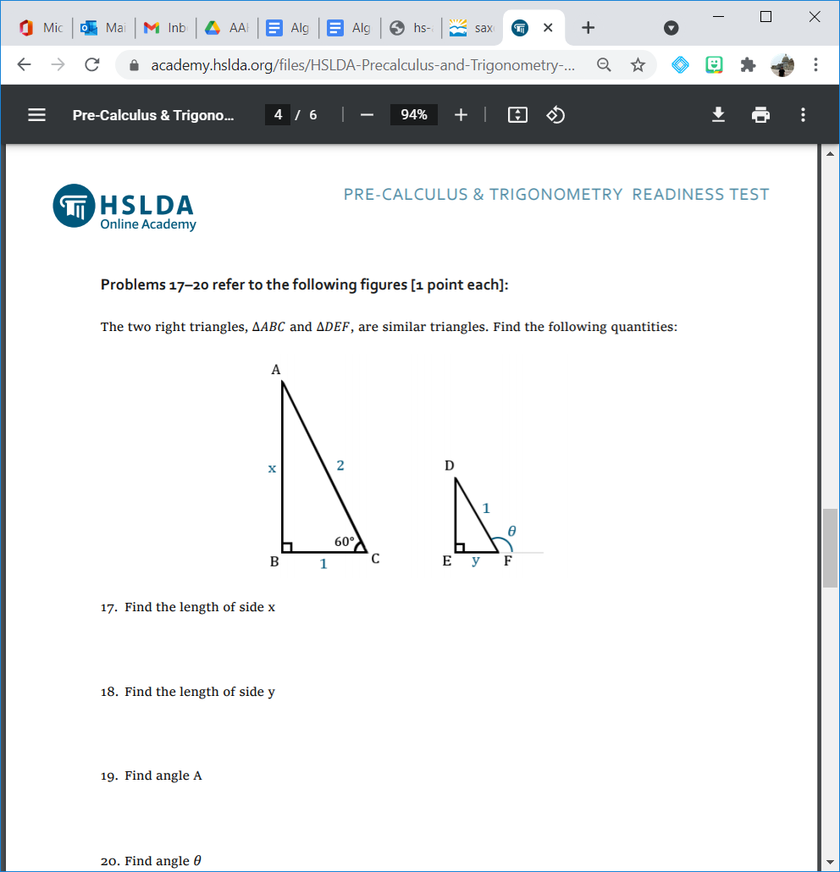

1. Find the length of side x.
2. Find the length of side y.

Answer Key

1. Vertex (-2,5) y-intercept -7 2.) 14+8i 3.) <math xmlns="http://www.w3.org/1998/Math/MathML" display="block" data-is-equatio="1" data-latex="x^2+2x-24"><msup><mi>x</mi><mn>2</mn></msup><mo>+</mo><mn>2</mn><mi>x</mi><mo>−</mo><mn>24</mn></math> 4.) <math xmlns="http://www.w3.org/1998/Math/MathML" display="block" data-is-equatio="1" data-latex="x^3+19x^2-x+9"><msup><mi>x</mi><mn>3</mn></msup><mo>+</mo><mn>19</mn><msup><mi>x</mi><mn>2</mn></msup><mo>−</mo><mi>x</mi><mo>+</mo><mn>9</mn></math> 5.) <math xmlns="http://www.w3.org/1998/Math/MathML" display="block" data-is-equatio="1" data-latex="-\frac{5}{7}"><mo>−</mo><mfrac><mn>5</mn><mn>7</mn></mfrac></math> 6.) <math xmlns="http://www.w3.org/1998/Math/MathML" display="block" data-is-equatio="1" data-latex="\log_61296=4"><msub><mi>log</mi><mn>6</mn></msub><mo data-mjx-texclass="NONE">⁡</mo><mn>1296</mn><mo>=</mo><mn>4</mn></math> 7.) <math xmlns="http://www.w3.org/1998/Math/MathML" display="block" data-is-equatio="1" data-latex="9x^8y^{12}"><mn>9</mn><msup><mi>x</mi><mn>8</mn></msup><msup><mi>y</mi><mrow data-mjx-texclass="ORD"><mn>12</mn></mrow></msup></math> 8.) <math xmlns="http://www.w3.org/1998/Math/MathML" display="block" data-is-equatio="1" data-latex="\frac{3m-7}{\left(m-5\right)\left(m+5\right)}\ \text{or}\ \frac{3m-7}{m^2-25}"><mfrac><mrow><mn>3</mn><mi>m</mi><mo>−</mo><mn>7</mn></mrow><mrow><mrow data-mjx-texclass="INNER"><mo data-mjx-texclass="OPEN">(</mo><mi>m</mi><mo>−</mo><mn>5</mn><mo data-mjx-texclass="CLOSE">)</mo></mrow><mrow data-mjx-texclass="INNER"><mo data-mjx-texclass="OPEN">(</mo><mi>m</mi><mo>+</mo><mn>5</mn><mo data-mjx-texclass="CLOSE">)</mo></mrow></mrow></mfrac><mtext></mtext><mtext>or</mtext><mtext></mtext><mfrac><mrow><mn>3</mn><mi>m</mi><mo>−</mo><mn>7</mn></mrow><mrow><msup><mi>m</mi><mn>2</mn></msup><mo>−</mo><mn>25</mn></mrow></mfrac></math> 9.) -8, 1 10.) (0,-5) 11.) <math xmlns="http://www.w3.org/1998/Math/MathML" display="block" data-is-equatio="1" data-latex="3\sqrt[8]{x^3}"><mn>3</mn><mroot><msup><mi>x</mi><mn>3</mn></msup><mn>8</mn></mroot></math>12.) x=8 13.) x=-20 14.) <math xmlns="http://www.w3.org/1998/Math/MathML" display="block" data-is-equatio="1" data-latex="\frac{x+5}{x+3}"><mfrac><mrow><mi>x</mi><mo>+</mo><mn>5</mn></mrow><mrow><mi>x</mi><mo>+</mo><mn>3</mn></mrow></mfrac></math>15.)<math xmlns="http://www.w3.org/1998/Math/MathML" display="block" data-is-equatio="1" data-latex="y=\frac{5}{7}x+\frac{31}{7}"><mi>y</mi><mo>=</mo><mfrac><mn>5</mn><mn>7</mn></mfrac><mi>x</mi><mo>+</mo><mfrac><mn>31</mn><mn>7</mn></mfrac></math> 16.) <math xmlns="http://www.w3.org/1998/Math/MathML" display="block" data-is-equatio="1" data-latex="x=-10"><mi>x</mi><mo>=</mo><mo>−</mo><mn>10</mn></math> 17.) <math xmlns="http://www.w3.org/1998/Math/MathML" display="block" data-is-equatio="1" data-latex="2\sqrt{5}"><mn>2</mn><msqrt><mn>5</mn></msqrt></math> 18.) <math xmlns="http://www.w3.org/1998/Math/MathML" display="block" data-is-equatio="1" data-latex="-\frac{2}{13}+\frac{16}{13}i"><mo>−</mo><mfrac><mn>2</mn><mn>13</mn></mfrac><mo>+</mo><mfrac><mn>16</mn><mn>13</mn></mfrac><mi>i</mi></math> 19.) <math xmlns="http://www.w3.org/1998/Math/MathML" display="block" data-is-equatio="1" data-latex="\sqrt{3}"><msqrt><mn>3</mn></msqrt></math> 20.) <math xmlns="http://www.w3.org/1998/Math/MathML" display="block" data-is-equatio="1" data-latex="\frac{1}{2}"><mfrac><mn>1</mn><mn>2</mn></mfrac></math>

Scoring Guidelines

70% or higher (14 or more correct): Precalculus/Trigonometry recommended

Under 70% (0-13 correct): Algebra II recommended