**Algebra I**

This course is intended for students who will be taking Algebra I during the upcoming school year, or who have already taken Algebra I and are looking for review and reinforcement. **This course assumes an understanding of all Pre-Algebra topics**. Please take the Algebra I placement test before registering. A score of 70% or higher is recommended to enroll in this course.

**Course Topics**: Real Numbers, Variables and Expressions, Solving Equations, Functions (Linear, Quadratic, Radical and Rational), Inequalities (Solving and Graphing), Systems of Equations and Inequalities, Exponents, Polynomials, Statistics, Probability and Introductory Trigonometry

**Algebra I Placement Test**

Complete the following questions without the use of a calculator.

1. Divide (round to two decimal places): <math xmlns="http://www.w3.org/1998/Math/MathML" display="block" data-is-equatio="1" data-latex="\frac{431.25}{61}"><mfrac><mn>431.25</mn><mn>61</mn></mfrac></math>
2. Write <math xmlns="http://www.w3.org/1998/Math/MathML" display="block" data-is-equatio="1" data-latex="\frac{6}{15}"><mfrac><mn>6</mn><mn>15</mn></mfrac></math>as a fraction with denominator 20.
3. Simplify <math xmlns="http://www.w3.org/1998/Math/MathML" display="block" data-is-equatio="1" data-latex="\frac{720}{2000}"><mfrac><mn>720</mn><mn>2000</mn></mfrac></math>.
4. The average time for four-400 meter runs was 53.4 seconds. If the first run was 52.7 seconds, the second run was 53.3 seconds and the third run was 54.1 seconds, what was the time for the fourth run?
5. What number is <math xmlns="http://www.w3.org/1998/Math/MathML" display="block" data-is-equatio="1" data-latex="\frac{7}{13}"><mfrac><mn>7</mn><mn>13</mn></mfrac></math> of <math xmlns="http://www.w3.org/1998/Math/MathML" display="block" data-is-equatio="1" data-latex="143"><mn>143</mn></math> ?
6. Write <math xmlns="http://www.w3.org/1998/Math/MathML" display="block" data-is-equatio="1" data-latex="\frac{107}{13}"><mfrac><mn>107</mn><mn>13</mn></mfrac></math> as a mixed number.
7. Find the least common multiple of 16, 21 and 24.
8. What number is 160 percent of 90?
9. Simplify using the Order of Operations: <math xmlns="http://www.w3.org/1998/Math/MathML" display="block" data-is-equatio="1" data-latex="5(16+3)-6\times2+1"><mn>5</mn><mo stretchy="false">(</mo><mn>16</mn><mo>+</mo><mn>3</mn><mo stretchy="false">)</mo><mo>−</mo><mn>6</mn><mo>×</mo><mn>2</mn><mo>+</mo><mn>1</mn></math>
10. Solve for x:

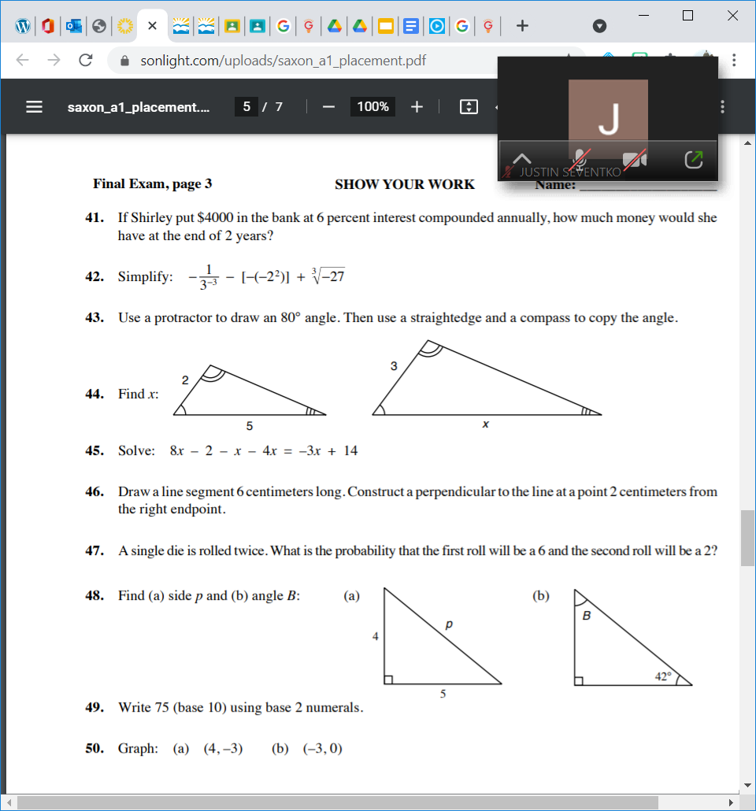

1. Solve <math xmlns="http://www.w3.org/1998/Math/MathML" display="block" data-is-equatio="1" data-latex="8x-2-x-4x=-3x+14"><mn>8</mn><mi>x</mi><mo>−</mo><mn>2</mn><mo>−</mo><mi>x</mi><mo>−</mo><mn>4</mn><mi>x</mi><mo>=</mo><mo>−</mo><mn>3</mn><mi>x</mi><mo>+</mo><mn>14</mn></math>
2. The ratio of knicks to knacks was 5 to 2. If 2100 were knicks, how many were knacks?
3. Evaluate the expression: 6a + 2b – 6c + 4, if a=3, b=5 and c= -1.
4. Find the perimeter of a rectangle with a width of (2x + 3) and a length of 2x.
5. Find the greatest common factor of 260, 80, 50.
6. Find the quotient and write it in simplest form <math xmlns="http://www.w3.org/1998/Math/MathML" display="block" data-is-equatio="1" data-latex="3\ \frac{3}{8}\div\frac{1}{4}"><mn>3</mn><mtext></mtext><mfrac><mn>3</mn><mn>8</mn></mfrac><mo>÷</mo><mfrac><mn>1</mn><mn>4</mn></mfrac></math>
7. Solve for x: <math xmlns="http://www.w3.org/1998/Math/MathML" display="block" data-is-equatio="1" data-latex="\frac{3}{4}=\frac{12}{x-5}"><mfrac><mn>3</mn><mn>4</mn></mfrac><mo>=</mo><mfrac><mn>12</mn><mrow><mi>x</mi><mo>−</mo><mn>5</mn></mrow></mfrac></math>
8. A t-shirt that normally costs $21.95 is on sale at a 15% discount. What is the sale price?
9. Translate the following sentence into an equation. Then, find its solution.

“If six is decreased by four times a number n, the result is twelve.”

1. Write 68% as both a decimal and fraction in simplest form.

Answer Key

1. 7.07 2.) <math xmlns="http://www.w3.org/1998/Math/MathML" display="block" data-is-equatio="1" data-latex="\frac{8}{20}"><mfrac><mn>8</mn><mn>20</mn></mfrac></math> 3.) <math xmlns="http://www.w3.org/1998/Math/MathML" display="block" data-is-equatio="1" data-latex="\frac{9}{25}"><mfrac><mn>9</mn><mn>25</mn></mfrac></math>4.) 53.5 5.) 77 6.) <math xmlns="http://www.w3.org/1998/Math/MathML" display="block" data-is-equatio="1" data-latex="8\ \frac{3}{13}"><mn>8</mn><mtext></mtext><mfrac><mn>3</mn><mn>13</mn></mfrac></math> 7.) 336 8.) 144 9.) 84 10.) <math xmlns="http://www.w3.org/1998/Math/MathML" display="block" data-is-equatio="1" data-latex="x=\frac{15}{2}"><mi>x</mi><mo>=</mo><mfrac><mn>15</mn><mn>2</mn></mfrac></math> 11.) <math xmlns="http://www.w3.org/1998/Math/MathML" display="block" data-is-equatio="1" data-latex="x=\frac{8}{3}"><mi>x</mi><mo>=</mo><mfrac><mn>8</mn><mn>3</mn></mfrac></math> 12.) 2940 13.) 38 14.) 8x + 6 15.) 10 16.) <math xmlns="http://www.w3.org/1998/Math/MathML" display="block" data-is-equatio="1" data-latex="13\ \frac{1}{2}"><mn>13</mn><mtext></mtext><mfrac><mn>1</mn><mn>2</mn></mfrac></math> 17.) x=21 18.) $18.66 19.) 6-4n=12; n=-3/2 20.) <math xmlns="http://www.w3.org/1998/Math/MathML" display="block" data-is-equatio="1" data-latex="\frac{17}{25}"><mfrac><mn>17</mn><mn>25</mn></mfrac></math>, .68

Scoring Guidelines

70% or higher (14 or more correct): Algebra I recommended

Under 70% (0-13 correct): Pre-Algebra VAAH Course Recommended